15.57: a) 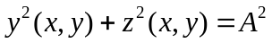

The trajectory is a circle of radius 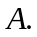

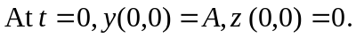

b)

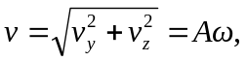 so the speed is constant.

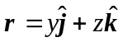

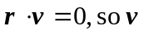 is tangent to the circular path.

c)

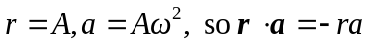

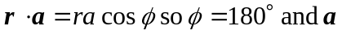 is opposite in direction to 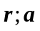 is radially inward.
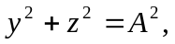 so the path is again circular, but the particle rotates in the opposite sense compared to part (a ).

